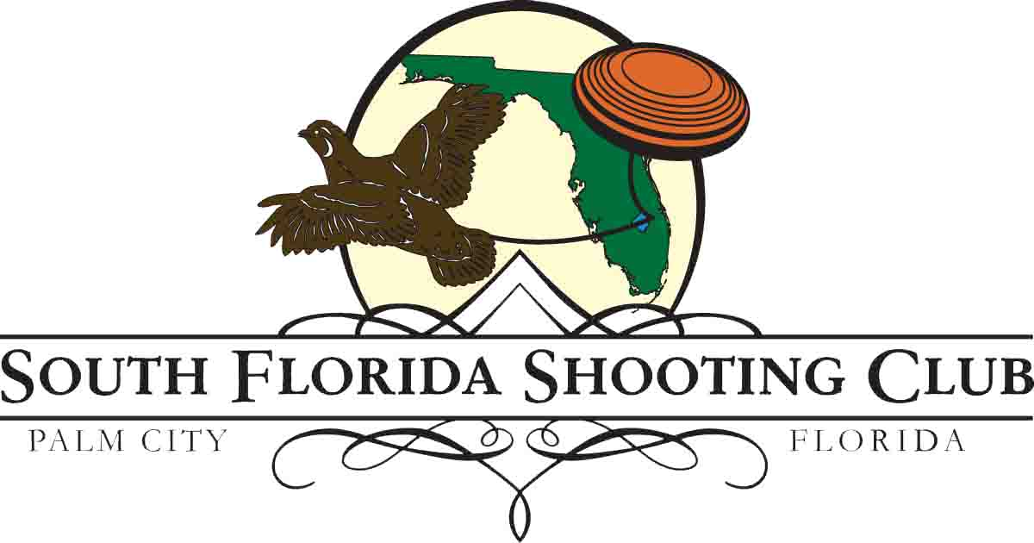

Official Invitation

The South Florida Shooting Club cordially invites (Insert Name) to the
2020 Krieghoff Classic, January 30- February 2, 2020

Please consider this document as confirmation to attend a competitive shooting event, sponsored and hosted by a NSCA registered shotgun club in Palm City, Florida that is devoted to the competitive and sporting use of firearms.

The South Florida Shooting Club is located at the following physical address:
500 SW Long Drive
Palm City, FL 34990

Please contact the South Florida Shooting Club with inquiries.
Telephone: 772.597.5852
Fax: 772.597.5876
Email: kristin@southfloridashootingclub.com
www.southfloridashootingclub.com

Sincerely,
South Florida Shooting Club

